FINCORE DIGITAL BANKING MANAGEMENT
PLATFORM
MILESTONE 2

Core Modules

EMI Calculation
Loan Disbursement
Collections

Team Members

Bharati Bhat
Ramya Chava
Janhvi Pandey
Indu Patil
Shanmukha Sai
Raziya

1. Abstract
FinCore Digital Banking Management Platform is a full-stack banking application designed to support secure and efficient digital banking operations. Milestone 2 extends the foundation established in Milestone 1 into the loan servicing area, focusing on EMI calculation, loan disbursement, and EMI collections. A Loan Servicing Summary dashboard provides an integrated view of loan information and navigation across the milestone modules.
The frontend is implemented using Angular 22 and TypeScript. The backend is implemented using Java and Spring Boot with Spring Data JPA and a layered controller-service-repository structure. PostgreSQL is used as the relational database for persistent storage. The milestone provides REST APIs, domain entities, DTOs, repositories, business services, validation, EMI schedule generation, disbursement tracking, payment collection, overdue handling, and a responsive banking-oriented user interface.
The milestone also introduces a relational loan data model connecting loans, disbursements, EMIs, and collections. The supplied PostgreSQL database design includes supporting customer, account, and loan transaction information, together with procedures, views, constraints, and indexes for loan-management operations.

2. Introduction
Loan servicing is a major part of a digital banking platform because sanctioned loans must be converted into repayment schedules, released to beneficiaries, and monitored throughout their repayment lifecycle. Manual calculation of EMIs, disbursement tracking, and collection recording can create delays and data inconsistencies.
FinCore Milestone 2 addresses these requirements by providing a connected loan-management workspace. The EMI module calculates the monthly installment and total repayment values and can generate an amortization schedule. The disbursement module records release amounts, beneficiary accounts, dates, reference numbers, and status. The collections module records EMI payments, determines remaining amounts, handles partial and full payments, and identifies overdue collections.
This milestone builds on the account, balance, and statement foundation established in Milestone 1. Milestone 1 defined the Angular–Spring Boot–PostgreSQL architecture and core banking data management capabilities

3. Problem Statement
Loan servicing activities such as EMI calculation, repayment schedule preparation, loan disbursement, and EMI collection are often handled through separate processes. This can make it difficult to maintain a consistent view of loan balances, payment status, overdue amounts, and transaction history.
FinCore Milestone 2 provides an integrated loan-management layer that connects loan information with EMI schedules, disbursement records, and collection records. The system applies validation at the service and database levels and exposes REST endpoints so that the Angular interface can interact with the Spring Boot backend.

4. Objectives
- Implement an EMI calculation module for principal, annual interest rate, and tenure.
- Calculate monthly EMI, total interest, and total repayment amount.
- Generate a detailed amortization schedule showing principal, interest, EMI, due date, and remaining balance.
- Implement a loan disbursement module for releasing sanctioned loan amounts and maintaining disbursement records.
- Validate disbursement amounts and maintain unique disbursement reference numbers.
- Implement an EMI collections module for recording customer payments.
- Support full and partial EMI payments and update the corresponding EMI status.
- Identify overdue EMIs and maintain days-overdue information.
- Provide a Loan Servicing Summary dashboard for integrated loan monitoring.
- Store loan-management data in PostgreSQL using relational tables, keys, constraints, indexes, procedures, and views.
- Provide RESTful APIs through Spring Boot for EMI, disbursement, and collection operations.
- Provide an interactive Angular interface for loan servicing activities.

5. Scope of Milestone 2
The scope of Milestone 2 consists of three core functional modules, supported by a Loan Servicing Summary workspace.
Module | Main Functionality
EMI Calculation | EMI calculation, total interest/repayment calculation, amortization schedule generation, schedule retrieval.
Loan Disbursement | Loan selection, eligibility/remaining amount display, disbursement amount entry, beneficiary account, date/mode, validation, status and reference tracking.
Collections | EMI due information, payment recording, payment validation, full/partial payment status, overdue tracking, and collection audit history.
Loan Servicing Summary | Integrated loan overview, portfolio metrics, customer/loan details, EMI information, disbursement flow reference, and navigation to milestone modules.

The milestone focuses on loan servicing functionality and does not redefine the account lifecycle, balance management, or statement-generation modules completed in Milestone 1.

6. Technology Stack
Category | Technology / Component
Frontend | Angular 22, TypeScript, HTML, CSS
Backend | Java, Spring Boot
Persistence | Spring Data JPA, Hibernate
Database | PostgreSQL
API Style | RESTful HTTP APIs
Build / Package | Maven, npm
Frontend Reactive Support | RxJS / Angular services
Development | VS Code / IntelliJ-compatible Maven project structure

The frontend project declares Angular 22 packages and TypeScript, while the backend uses Spring Boot with Spring Data JPA, Spring Web, Lombok, and Maven. The report presents PostgreSQL as the project database, consistent with the supplied Milestone 2 PostgreSQL database script and ER design.

7. System Architecture
FinCore Milestone 2 follows a layered full-stack architecture. The Angular frontend provides the user interface and module navigation. Angular services manage module data and interactions. REST requests are handled by Spring Boot controllers, which delegate business operations to service classes. Repository classes provide persistence access through Spring Data JPA, while PostgreSQL stores the relational loan data.
The overall flow is:
Angular UI → Angular Services → REST API → Spring Boot Controllers → Service Layer → JPA Repositories → PostgreSQL
The backend separates EMI, disbursement, and collection functionality into dedicated packages containing controllers, services, repositories, entities, and DTOs. The frontend similarly separates EMI, disbursement, collections, and loan-servicing components.
Layer | Milestone 2 Responsibility
Presentation | Angular components for EMI, disbursement, collections, and loan servicing.
Frontend Services | Data handling and module operations through services such as EMI, Disbursement, and Collection services.
API Layer | REST controllers under /api/emi, /api/disbursement, and /api/collection.
Business Layer | EMI calculation/schedule generation, disbursement validation/status management, and collection/payment processing.
Persistence Layer | Spring Data JPA repositories for loans, EMIs, disbursements, and collections.
Database | PostgreSQL tables, constraints, indexes, procedures, and views for loan management.

8. Module 1 – EMI Calculation and Amortization
The EMI Calculation module calculates the fixed monthly repayment for a loan and provides a complete amortization schedule. The module accepts the principal amount, annual interest rate, loan tenure, tenure unit, repayment frequency, and first EMI date in the frontend. The backend calculation request contains the principal amount, annual interest rate, and number of months.

8.1 EMI Inputs
- Loan / principal amount.
- Annual interest rate in percentage per a
- Loan tenure in months after conversion of the selected tenure unit.
- Repayment frequency, with the interface supporting monthly, quarterly, and annual selections.
- First EMI date for schedule presentation.

8.2 EMI Calculation
The backend uses the standard reducing-balance EMI calculation. The monthly interest rate is derived from the annual rate by dividing by 12 and by 100. The calculated EMI is rounded to two decimal places.
EMI = P × r × (1 + r)^n / ((1 + r)^n − 1)
Here, P represents the principal amount, r represents the monthly interest rate, and n represents the number of monthly installments. Total repayment is calculated as EMI multiplied by the number of months, and total interest is the difference between total repayment and principal.

8.3 Amortization Schedule
The schedule generation logic iterates through each installment. For every installment, interest is calculated from the opening outstanding balance. The principal component is the EMI minus the interest component, and the remaining balance is reduced by the principal component. The generated schedule contains installment number, due date, EMI amount, principal component, interest component, amount paid, payment date, and status.

8.4 Backend Implementation
- EMIController exposes calculation and schedule endpoints.
- EMIService contains the EMI formula, total repayment calculation, schedule generation, and schedule retrieval logic.
- EMIEntity stores installment-level data such as due date, EMI amount, principal amount, interest amount, amount paid, payment date, and status.
- EMIRepo retrieves EMI records in installment-number order for a loan.
- DTOs separate calculation requests and responses from the persistence entity.
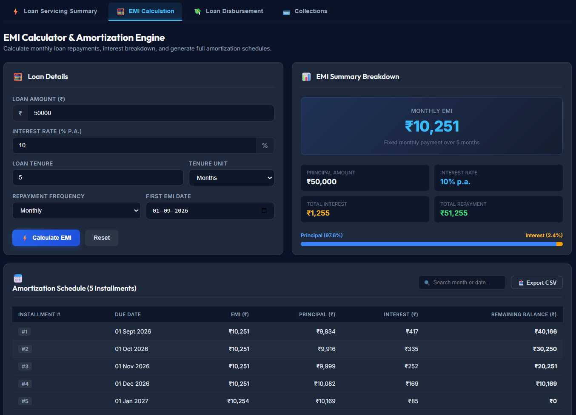
Figure 2: EMI Calculation and Amortization Interface

9. Module 2 – Loan Disbursement
The Loan Disbursement module manages the release of a sanctioned loan amount to a beneficiary account. The interface first allows a loan to be selected and displays the customer, loan type, credit score, loan status, sanctioned amount, already-disbursed amount, and eligible remaining amount.

9.1 Disbursement Workflow
- Select an active or approved loan.
- Review the loan overview and eligible amount available for disbursement.
- Enter the disbursement amount and beneficiary bank account.
- Select the disbursement date and mode and provide remarks/purpose.
- Validate the requested amount.
- Create the disbursement record with a unique reference number and status.
- Allow the disbursement status to be retrieved or updated.

9.2 Validation and Backend Logic
- The requested disbursement amount must be greater than zero.
- The backend rejects a disbursement amount greater than the loan principal amount.
- The loan must exist before a disbursement is created.
- A unique reference number is generated for the disbursement record.
- Disbursement records are associated with their loan through a foreign-key relationship.
- The status can be maintained through a dedicated status-update endpoint.

9.3 Data Captured
Field | Purpose
Loan ID | Identifies the loan being disbursed.
Amount | Amount released in the disbursement.
Disbursement Date | Date/time at which the release is recorded.
Reference Number | Unique identifier for the disbursement.
Beneficiary Account | Destination account for the released amount.
Status | Tracks the current state of the disbursement.
Remarks | Purpose or additional disbursement information.

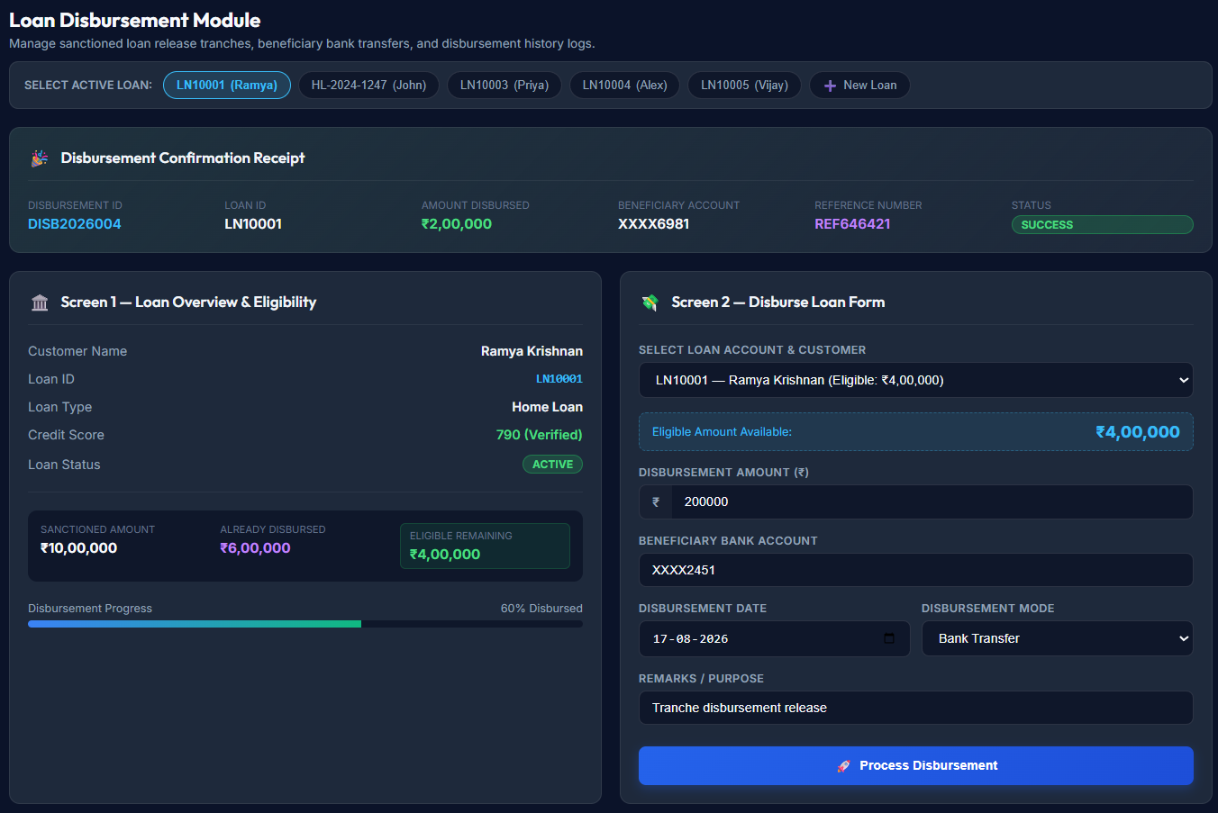
Figure 3: Loan Disbursement Interface

10. Module 3 – EMI Collections and Repayment Management
The Collections module records customer EMI payments and monitors repayment status. It combines a repayment-status view with a collection-entry form and a payment collection audit trail.

10.1 Collection Dashboard
The interface presents high-level collection indicators such as total active loans, EMIs due today, EMIs paid today, overdue EMIs, and total outstanding amount. These indicators provide a quick view of the repayment portfolio.

10.2 Payment Recording
- Select the customer loan account.
- Review the borrower, loan account, EMI due amount, due date, outstanding principal, and current EMI status.
- Enter the payment amount.
- Select the payment mode and provide a transaction/reference identifier.
- Enter the payment date and remarks.
- Record the collection payment.
- Update the EMI status as fully paid or partially paid and refresh the payment history.

10.3 Backend Collection Logic
- A collection is associated with an EMI record.
- The system calculates the remaining amount as amount due minus amount collected.
- Payment amounts must be greater than zero.
- A payment greater than the remaining amount is rejected.
- When the collected amount equals the amount due, the collection and EMI are marked as PAID.
- When the collected amount is less than the amount due, the collection and EMI are marked as partially paid.
- Payment date and amount-paid information are updated on the corresponding EMI.
- Overdue collections are identified by comparing the due date with the current date and storing the number of overdue days.

10.4 Collection Audit Trail
The payment history table provides an auditable view of payment date, payment ID, loan ID, customer, amount, payment mode, reference number, and EMI status. This supports traceability of collection activities.
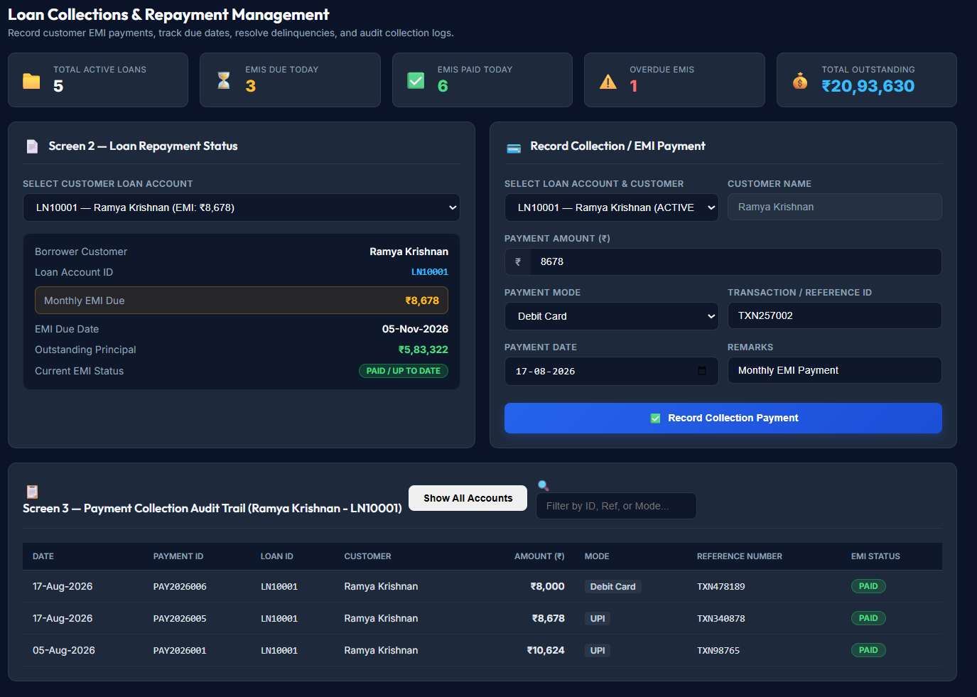
Figure 4: Loan Collections and Repayment Management Interface

11. Loan Servicing Summary – Supporting Workspace
The Loan Servicing Summary acts as the integrated workspace for Milestone 2. It provides a consolidated loan view and links the user to EMI calculation, loan disbursement, and collections. The displayed summary includes active-loan information, disbursed amount, NPA ratio, loan/customer details, EMI, tenure, interest rate, disbursement flow information, EMI schedule information, and servicing actions.
The frontend application uses module tabs and sidebar navigation to switch between the servicing summary, EMI calculation, disbursement, and collections views. This provides a consistent user experience across the milestone.
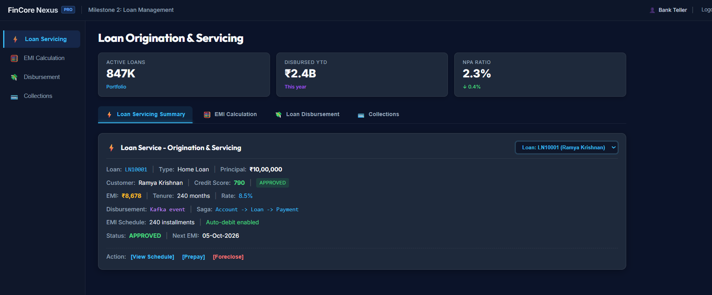
Figure 5: Loan Origination and Servicing Summary Interface

12. Database Design
PostgreSQL is used as the relational database for Milestone 2. The supplied database design contains customer, account, loan, disbursement, EMI schedule, EMI collection, and loan transaction tables. Primary keys uniquely identify records, while foreign keys connect loan-management records to their parent entities.

Table | Purpose
customers | Stores customer identity, contact information, address, and creation information.
accounts | Stores customer-linked account numbers, account type, balance, status, and opening date.
loans | Stores loan number/type, principal, interest rate, tenure, EMI values, disbursed amount, outstanding principal, status, and lifecycle dates.
loan_disbursement | Stores loan release amount, beneficiary account, disbursement date, status, reference number, and remarks.
emi_schedule | Stores installment number, due date, opening/closing principal, EMI, principal component, interest component, paid amount, remaining amount, and status.
emi_collections | Stores EMI payment amount, payment date, payment method, transaction reference, collection status, and remarks.
loan_transactions | Maintains loan-level financial transaction records such as disbursement and EMI payment transactions.

12.1 Entity Relationships
- One loan can have one or more disbursement records.
- One loan can have many EMI records.
- One EMI can have one or more collection records.
- Loan records are linked to customer and account records through foreign keys.
- Loan transactions are linked to the corresponding loan and customer.
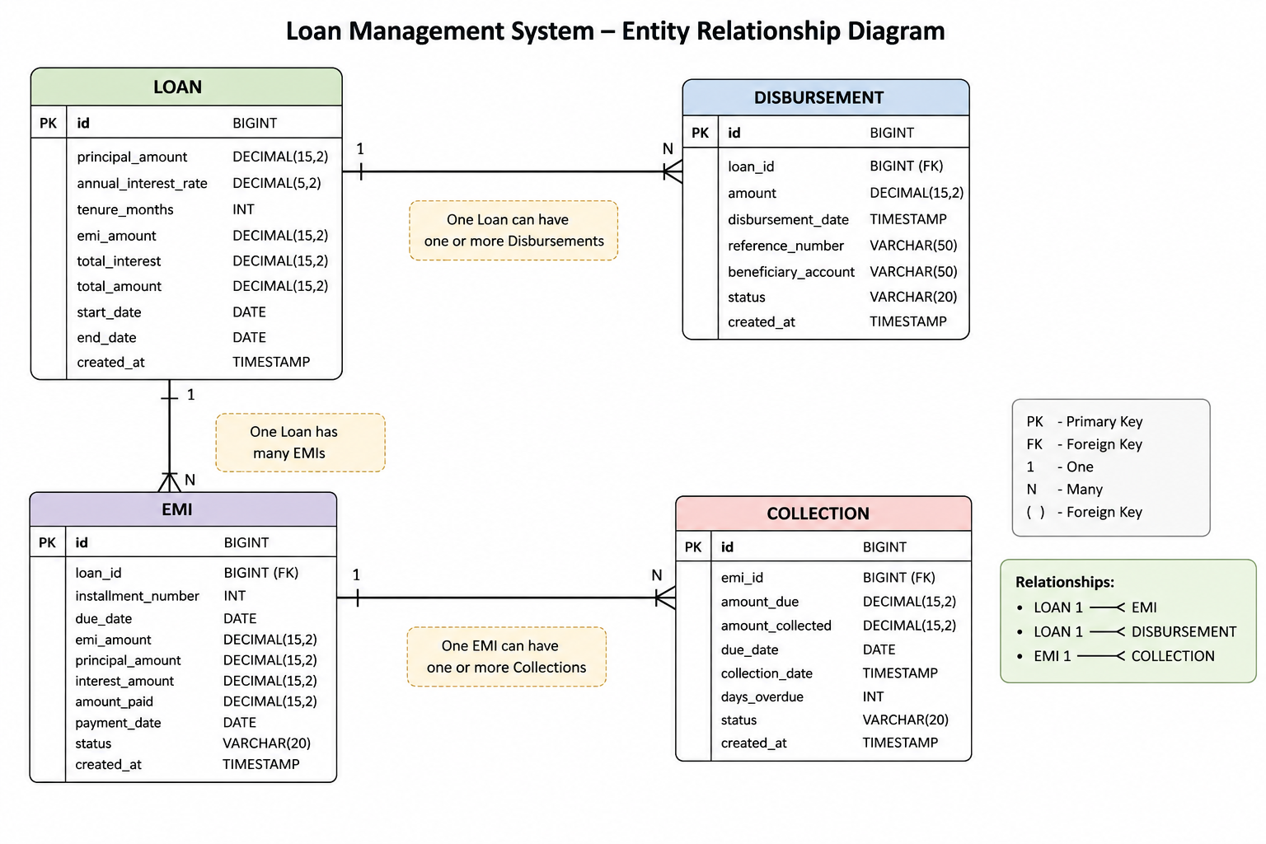
Figure 1: Loan Management Entity Relationship Diagram

12.2 Database Integrity and Performance
- Primary keys provide unique record identification.
- Foreign keys maintain relationships among customers, accounts, loans, disbursements, EMIs, collections, and transactions.
- Positive-value checks are applied to principal amounts, interest-related monetary values, disbursement amounts, and payment amounts.
- Loan, EMI, and collection status values are restricted to defined states.
- Unique constraints are applied to identifiers such as customer email/phone, loan number, and transaction/reference values where defined.
- Indexes are created on frequently queried fields including customer, loan, EMI, due-date, status, and collection relationships.
- PostgreSQL functions and procedures support EMI calculation, schedule generation, disbursement, EMI collection, and overdue marking.
- Database views provide consolidated loan summary, EMI collection status, and overdue EMI information.
The supplied PostgreSQL script defines a calculate_emi function, generate_emi_schedule procedure, disburse_loan procedure, collect_emi procedure, and mark_overdue_emis procedure. It also defines loan_summary, emi_collection_status, and overdue_emis views.

13. API Design
The Spring Boot backend exposes REST endpoints for the three core modules. Controllers receive requests, invoke service-layer operations, and return response DTOs.
Module | Method | Endpoint | Purpose
EMI | GET | /api/emi/calculate | Calculate EMI, total repayment, and total interest.
EMI | POST | /api/emi/schedule/{loanId} | Generate an EMI schedule for a loan.
EMI | GET | /api/emi/loan/{loanId} | Retrieve EMI records for a loan.
Disbursement | POST | /api/disbursement | Create a disbursement record.
Disbursement | GET | /api/disbursement/{id} | Retrieve a disbursement by ID.
Disbursement | GET | /api/disbursement/loan/{id} | Retrieve disbursements for a loan.
Disbursement | PATCH | /api/disbursement/{id}/status | Update disbursement status.
Collections | POST | /api/collection | Create a collection record.
Collections | GET | /api/collection/{id} | Retrieve a collection by ID.
Collections | GET | /api/collection/loan/{loanId} | Retrieve collections for a loan.
Collections | GET | /api/collection/overdue | Retrieve overdue collections.
Collections | POST | /api/collection/{id}/payment | Record a payment against a collection.

14. User Interface Implementation
The Angular interface is organized into reusable components for the header, sidebar, metrics header, loan servicing summary, EMI calculator, disbursement, and collections. The main application switches between the milestone views through module tabs and sidebar navigation.
- The EMI interface contains loan-detail inputs, an EMI summary panel, principal/interest distribution, an amortization schedule, search support, and CSV export control.
- The disbursement interface contains active-loan selection, loan overview and eligibility information, disbursement form fields, and a process-disbursement action.
- The collections interface contains dashboard metrics, loan repayment status, payment-entry fields, and a payment audit trail.
- The servicing summary provides a consolidated loan view and navigation to the three core modules.

15. Testing and Validation
Testing for Milestone 2 focuses on functional correctness of the EMI calculation, disbursement validation, collection processing, schedule generation, status transitions, and frontend interactions. The backend project also contains a Spring Boot application-context test setup.

Test Area | Test Condition | Expected Result
EMI Calculation | Valid principal, rate, and tenure | Monthly EMI, total interest, and total repayment are calculated.
EMI Calculation | Zero/invalid calculation inputs | Invalid values are rejected or do not produce a valid EMI result.
Schedule Generation | Valid loan ID | Installments are generated with due dates and principal/interest components.
Schedule Retrieval | Existing loan ID | EMIs are returned in installment order.
Disbursement | Positive amount within allowed loan amount | Disbursement record is created with reference number and status.
Disbursement | Amount greater than loan amount | Request is rejected.
Disbursement | Unknown loan | Request is rejected with loan-not-found handling.
Collections | Positive payment within remaining amount | Collection is recorded and remaining amount is updated.
Collections | Payment exceeds remaining amount | Payment is rejected.
Collections | Payment completes EMI | Collection and EMI become PAID.
Collections | Payment is less than amount due | Collection and EMI become partially paid.
Overdue | Due date has passed and amount remains | Collection/EMI can be identified as overdue.
UI | Navigation between milestone tabs | Correct module view is displayed.

16. Results and Outcomes
Milestone 2 establishes the loan servicing layer of the FinCore platform. The implemented modules provide EMI calculation and schedule generation, loan disbursement management, and EMI collection management. The supporting servicing summary consolidates loan information and provides navigation across the milestone.
The demonstrated EMI interface calculates a monthly EMI and presents principal, interest, total repayment, and a five-installment amortization schedule for the displayed sample inputs. The disbursement interface demonstrates eligibility tracking, tranche release entry, beneficiary account information, and successful disbursement status. The collections interface demonstrates EMI payment entry, repayment status, and an auditable payment history.
The PostgreSQL design strengthens the milestone through relational constraints, loan/EMI/collection relationships, indexes, database procedures, and reporting views. The supplied database script defines the core loan-management tables and the relationships required for EMI, disbursement, and collection processing

17. Conclusion
FinCore Digital Banking Management Platform Milestone 2 successfully extends the platform from core account and transaction capabilities into loan servicing. The EMI Calculation module provides accurate repayment calculations and amortization schedules. The Loan Disbursement module supports controlled release and tracking of sanctioned amounts. The Collections module supports payment recording, partial/full repayment handling, overdue identification, and collection history.
The combination of Angular 22, TypeScript, Java, Spring Boot, Spring Data JPA, Hibernate, and PostgreSQL provides a modular foundation for further loan-management capabilities. The relational database model, REST APIs, service-layer validation, and reusable frontend components make the milestone suitable for extension into additional banking workflows.

18. Team Members
Name | Role
Bharati Bhat | Frontend Developer
Ramya Chava | Frontend Developer
Janhvi Pandey | Backend Developer
Indu Patil | Database
Shanmukha Sai | Frontend Developer
Raziya | Backend Developer

